Consulting Report for Erin White
Prepared by Drew Olson

The executive summary
This study looked a comparing the percent body fat in three different variables: head above, head below, and the gold standard residual volume method. All three variable combinations had high correlations with each, meaning that they were very similar, with the head above and head below combination having the strongest correlation.

Research questions
- Is there a relationship between the head above water total lung capacity (HAWTLC) and the gold standard residual volume method (RV)?
- Is there a relationship between the head below water total lung capacity (HBWTLC) and the gold standard residual volume method (RV)?
- Is there a relationship between the head above water total lung capacity (HAWTLC) and the head below water total lung capacity (HBWTLC)?

Data
The data was condensed into 8 categories based off importance of research questions. Those columns are ID,Age,Ethnicity, SGPALS, Sex, Fat_HAWTLCall, FAT_HBWTLCall, and Fat_HBWRVal. After the data was condensed we used various analysis method to compare the measuring variables against each other.

Methods
Three different methods were used to test for significance and association between the three measuring variables (head above, head below, and the gold standard residual volume method). These methods were a pairwise plot and the correlation test that measures how similar the two variables being measures are. The last test was the t tests that compares the means between the comparisons that will test whether the two groups are different from each other. These three test were conducted on all three combinations.

*** Results

Plot 1 represents a pairwise comparisons which looks at the points individual pairs one at a time and correlational scatterplot to represent how strong the connection between the two variables. The bottom left corner is the Above water and the Residual Volume. The left middle is the Above water and Below water. The bottom middle is the Below water and the Residual Volume. The strength of a correlation is measured on plot by how close the points are to each other and if they create a linear trend (pointing a certain direction). By looking at the pairwise plot below you can see that they all have a fairly strong linear trend with points close together, the weakest relationship appearing to be the Above Water and Residual Volume comparison.

Table 1 represents the comparisons on a correlational test, which like the pairwise tests for a connection but it looks at the table instead of individually. Listed in the table are the correlation coefficients, which measure the strength of the relationship. The closer the number is to negative one or one, the stronger the relationship. As seen by our pairwise plot the weakest relationship as well was the Above water and Residual volume with a correlation of 0.88 and the strongest relationship was the Above water and below water with a relationship of 0.97. The p-values are also listed, they show if the analysis was significant or valid enough. We tested it at a 0.5 significance level, so you would want the p-value to be less than that level, which they all were.

Table 2 is a look at the statistics of the t-test to check to see if there was a difference in the means. Mean 1 and Mean 2 are listed and they are just the overall means of the first and second measure which are separated by a ‘-‘ in the comparisons. The difference in the means is just a calculations to see the change in the mean between the two variables. And the p-value tests the significance of our test at 0.05. The above water to below water comparison tested with a very small p-value, which would mean that they are significantly different. The same can be said about the Below water and residual volume comparison. The above water and residual volume comparison however was not significant at 0.13 which is not less than 0.05. This means that although they had high correlation, their means were not significantly different enough to say that it was a meaning change.

Plot 1: Pairwise plot on the comparisons between the three types of measurements.

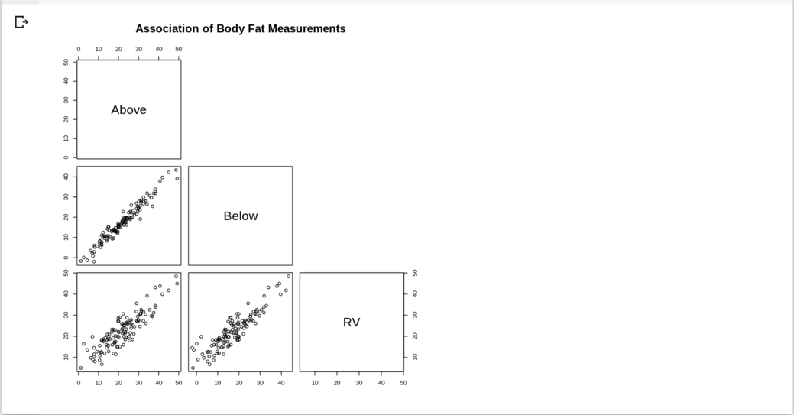

Table 1: Correlation coefficients and corresponding p-values for measure comparisons.
 | Correlation | P-Value
Above-RV | 0.88 | <2.2e-16
Below-RV | 0.90 | <2.2e-16
Above-Below | 0.97 | <2.2e-16
*Significance level 0.05

Table 2: T test comparing the difference in the means of the measure comparisons.
 | Mean1 (M1) | Mean2 (M2) | Diff in Means (M1-M2) | p-value
Above-RV | 22.23 | 22.69 | -0.63 | 0.13
Below-RV | 17.68 | 22.69 | -5.17 | <2.2e-16
Above-Below | 22.23 | 17.68 | 4.55 | <2.2e-16
*Significance level 0.05

Appendix
All Data Analysis was down in R colab. Link to colab below.

https://colab.research.google.com/drive/1cdVs5eMlfWTG7y7o8yRGM-VR0zzkSkCe?usp=sharing

